






Monthly Progress Report
December 2022

This document details the progress on research projects conducted in the Advanced Research & Innovation Centre over the month of December 2022

Table of Contents
1. Executive Summary 3
1.1 Vision Based Robotic Manufacturing 3
1.2 Lower-Limb Wearable Exoskeleton for Rehabilitation Assistance 3
1.3 Materials and Manufacturing 3
2. Progress Reports 5
2.1 A vision-based approach for robotic manufacturing 5
2.2 Lower-Limb Wearable Exoskeleton for Rehabilitation Assistance 15
2.3 Materials and Manufacturing: Non-destructive testing of Carbon Fiber Reinforced Thermoplastics. 19
2.4 Additive Manufacturing 22
3. 2022 KPI’s (2021 targets are quoted) 23
4. ARIC Visitors 26

Executive Summary

Vision Based Robotic Manufacturing

The work on this project during focused on December focused on finalizing and documenting the progress in 2022, with three articles being submitted / re-submitted and under review. For the work with STRATA, we are documenting the final prototype of the deburring end-effector prior to its qualification process and compiling a list of recommendations for the second prototype of the painting end-effector. We are also working on compiling invention disclosures for both end-effectors for potential patenting. We are also continuously enhancing the visual perception algorithms for STRATA’s robotic platform, and have submitted an article on Neuromorphic camera calibration to the IEEE Robotics and Automation Letters. As for the vision-based tactile sensor, we have revised our submission to the Journal of Intelligent Manufacturing and re-submitted the paper. As for the projects with SANAD, we are continuously enhancing the perception algorithms for the sorting robot to prepare the robot for operational testing in 2023. We are also in the process of collecting and processing extra data to improve the accuracy of our AI models for defect detection.

Lower-Limb Wearable Exoskeleton for Rehabilitation Assistance

Progress during the last month included working on the control and characterization of the compliant knee exoskeleton. Position control is deployed in order to follow the gait trajectory of the knee joint positions. The T-motor-embedded PD controller is used to tune the position controller. The controller is implemented using Quanser real-time DAQ. We have been revising the IRB application documents and consent forms according to the committee comments in order to move forward with the IRBs. We are still developing the neural network to predict gait kinematics based on previous EMG and IMU data. Transformer-based solutions for the long-term time series forecasting (LTSF) task are used for enhanced gait prediction. Furthermore, testing is being conducted on the comfort and wearability of the exoskeleton for enhanced grip and slipping reduction between the exoskeleton and the human. New special type of straps with more contact points will be used.

Materials and Manufacturing

Graphene-coated glass fiber tows have been used to monitor strain and detect damage in composite materials based on glass and carbon fiber reinforced epoxy resin. The graphene sensors were located at different locations within the thickness of the composite and monitored whilst the panels were subjected to out-of-plane loading by a hemispherical indentor. Initial tests on a glass fiber reinforced epoxy composite have shown that the sensors are capable of detecting strain as the plate is loaded transversely and ultimately they can detect the onset of damage associated with the onset of fiber fracture and localized delamination. Cyclic fatigue tests highlighted the repeatability of the sensors as well as their ability to withstand longer term loading. Tests were also undertaken on carbon fiber reinforced epoxy panels, where it is necessary to electrically-insulate the sensors from the conductive carbon fibers. Here again, it has been shown that these simple graphene-coated sensors are capable of monitoring the health of a load-bearing composite plate.

Progress Reports

A vision-based approach for robotic manufacturing

Project Objectives:

- The development of STRATA R&D MMO-500 robot to the qualification requirements.
- The development of the robotic deburring end-effector to the industrial specifications of STRATA.
- The development of a robotic painting end-effector for the inner-surface of drilled holes.
- The development of a robotic riveting end-effector.
- The development of a counter-sink inspection capability for the robotic machining platform.
- The research on dynamic vision optical sensing, as per our patent application 2020-034.
- The research on vision-based navigation to supplement the LiDAR system currently in use.
- The research on the integration of dynamic vision and light coding technology for faster surface inspection.
- The training of national Khalifa University students on robotic manufacturing technologies, including the mathematical fundamentals, robotic perception, mechanical design, and the operation of robots in the industry.
Cumulative and new project outputs regarding publications and IP

- Publication and IP updates in December:
  - We have re-submitted our article titled “A Novel Vision-based Multi-functional Sensor for Normality and Position Measurements in Precise Robotic Manufacturing” to the “Journal of Intelligent Manufacturing” after addressing the comments from the first review round.
  - We have submitted an article titled: “Novel Event-Driven Calibration of Bio-Inspired Neuromorphic Vision Sensors” to the IEEE Robotics and Automation Letters.

- Summary of IP during 2022:
  - 5 accepted and published articles:
    - “Real-Time Grasping Strategies Using Event Camera”
    - “Neuromorphic Vision Based Control for the Precise Positioning of Robotic Drilling Systems”
    - “Neuromorphic Camera Denoising using Graph Neural Network-driven Transformers”
    - “ConvMixer-based Unet for Segmentation Refinement of Unknown Objects in Cluttered Scenes”
    - “Elastomer-Based Visuotactile Sensor for Normality of Robotic Manufacturing Systems”

  - 3 articles under review:
    - “A Novel Vision-based Multi-functional Sensor for Normality
and Position Measurements in Precise Robotic Manufacturing”
    - “A Multi-Purpose Autonomous Cobot (Mobile Robot) System for Aerospace Machining Application”
    - “Novel Event-Driven Calibration of Bio-Inspired Neuromorphic Vision Sensors”

  - 2 articles in progress:
    - “Neuromorphic vision-based Countersink Inspection”
    - “Neuromorphic vision-based segmentation dataset”

  - 1 grant proposal submitted to Sandooq Al watan’s SWARD has been accepted for funding, AED4.2M.
  - 1 patent under review

2022 Project KPI Summary

- Targets (as indicated in Statement of Work)
- The publication of three journal articles
- The development of two industrial prototypes (one for STRATA and another for SANAD)
- The training of 6-8 undergraduate students

- Achievements
- Five accepted/published articles:
  - “Real-Time Grasping Strategies Using Event Camera” published in “Journal of Intelligent Manufacturing”.
  - “Neuromorphic Vision Based Control for the Precise Positioning of Robotic Drilling Systems” accepted for publication at “Robotics and Computed-Integrated Manufacturing”
  - “Neuromorphic Camera Denoising using Graph Neural Network-driven Transformers” accepted at the IEEE transactions on Neural Networks and Learning Systems.
  - “ConvMixer-based Unet for Segmentation Refinement of Unknown Objects in Cluttered Scenes” published at IEEE Access.
  - “Elastomer-Based Visuotactile Sensor for Normality of Robotic Manufacturing Systems” published in “MDPI Polymers”

- Three articles under review:
  - “A Novel Vision-based Multi-functional Sensor for Normality
and Position Measurements in Precise Robotic Manufacturing”
  - “A Multi-Purpose Autonomous Cobot (Mobile Robot) System for Aerospace Machining Application”
  - “Novel Event-Driven Calibration of Bio-Inspired Neuromorphic Vision Sensors”

- Two articles in progress:
  - “Neuromorphic vision-based countersink inspection”
  - “Neuromorphic vision-based segmentation dataset”

- Five industrial prototypes are in different stages of development:
  - The second prototype of deburring end-effector for STRATA is ready for qualification at STRATA.
  - A first prototype for painting end-effector for STRATA has been tested and verified.
  - Algorithms for visual inspection are being integrated and tested on STRATA’s drilling robot
  - A blade-sorting robot prototype for SANAD has been validated, with planned operational testing and demonstrations in 2023.
  - The development of AI tools for inspecting blades is in the early stages of development.

- The training of 16 undergraduate national students in 2022:
  - Five SDP students on laser-based inspection with STRATA
  - Five SDP students on robotic blade weighing with SANAD
  - One AI minor project on vision-based tactile sensing.
  - Five SDP students for students on 3D blade reconstruction with SANAD.

- Five graduate students supervised by Dr. Yahya Zweiri won the Outstanding Young Researcher and Top Journal Publication awards, out of a total of 37 students that received the award in all of KU’s departments, two PhD awardees from ARIC group.
- One patent under review by US patent office.
- One proposal was accepted for funding by Sandooq Al Watan.

Updates for this month:

- For the development of the multi-purpose machining end-effector (drilling, deburring, painting, and riveting):

  - Deburring end-effector:
- After finalizing the upgraded deburring tool end effector and getting its reliable results, we are now in the planning process for the following stages:
- Work with the STRATA R&D team to register the end effector and quantify its results by a third party based on BOEING standards and requirements.
- Producing another two end effector prototypes for testing and quantification purposes.
- Write the IP disclosure form that highlights the novelty in the end effector mechanism and the related application together.
  - Painting end-effector:
- After finishing the first prototype of the hole’s inner surface painting end effector, we are now in the planning process for the following stages:
- Optimize the dispensing mechanism by studying the replacement of the stepper motor-based mechanism with a pneumatic-based one in order to reduce the end effector complexity and reduce the overall weight.
- Optimize the sponge head principle for adding more accuracy to the painting results in order to meet industrial standards and give more reliability to the user.
- Write the IP disclosure form that shows the novelty in the end effector mechanism and the related application together.
- Expanding the end effector capabilities to do the chemical cleaning process before the painting.
    - KPI summary:
  - Industrial prototype for deburring is ready for qualification at STRATA.
  - The first prototype for the painting end-effector has been developed and tested. Improving this end-effector to make it ready for deployment of
  - We have finalized the upgrade of the mobile robot for STRATA
  - One article for the full multi-application system has been submitted to the journal of intelligent manufacturing.

- For the Counter-Sink Inspection Task:
  - CSK inspection with conventional cameras:
- We are still working with STRATA’s R&D team to integrate this capability on their robot using conventional vision.

  - CSK inspection with neuromorphic cameras:
- The counter-sink inspection task using the event camera faced technical difficulties in terms of the utilized neuromorphic vision sensor (Prophesee Gen2) because:
- The sensor biases either produce a very noisy output, or to tune these biases the sensor sensitivity to relative motion is highly reduced. Because of the aforementioned limitation, the edges features of the countersinks became degraded, see Fig. 1.
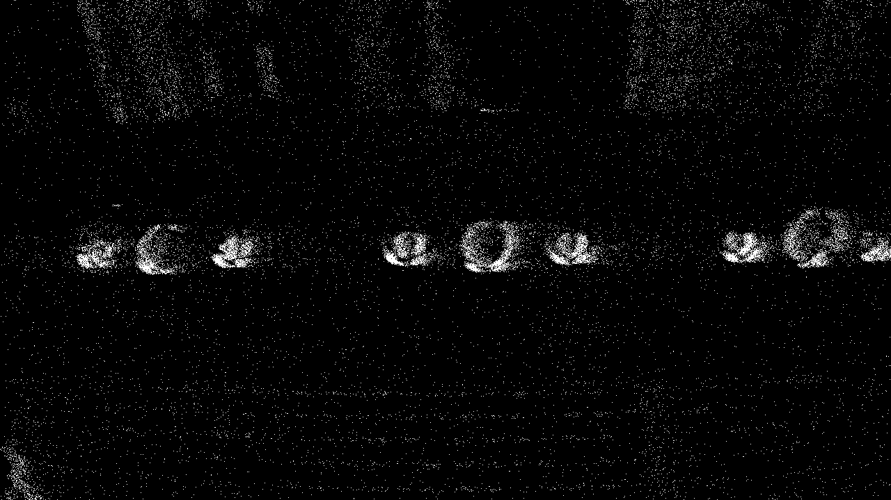
Figure 1: Degraded features of countersinks due to low sensor sensitivity.

- Also, because of the sensor noisy nature, extrinsic calibration performance did not achieve the desired accuracy and to perform warping, the performance was sub-optimal, see Fig. 2.
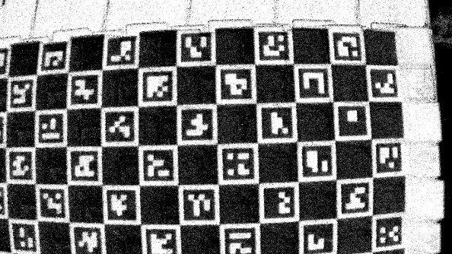\
Figure 2: Degraded quality of reconstructed images for calibration for Prophesee.
- Therefore we have changed our sensor for the DVXplorer with improved reconstruction quality and sensitivity to relative motion, see Fig. 3.

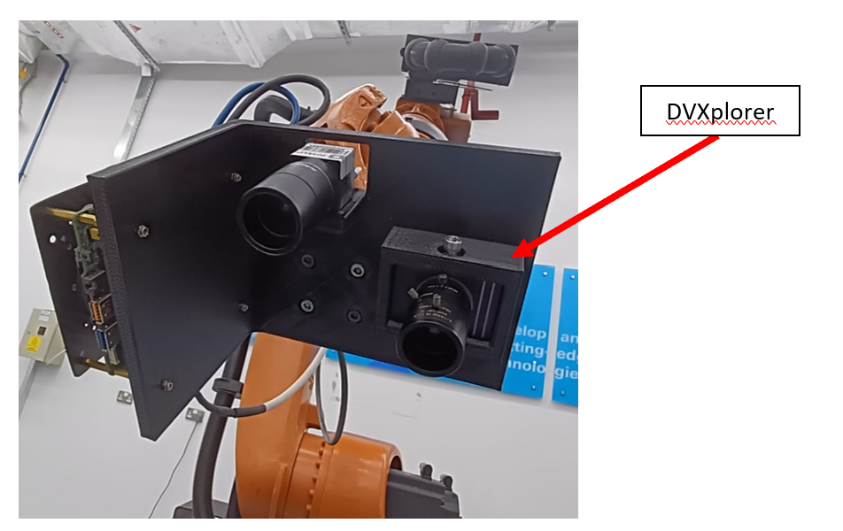
Figure 3: The new countersink inspection end-effector with the DVXplorer camera

- For enhanced performance, we have developed our own calibration software for neuromorphic vision sensors. Which has been submitted for publication to IEEE Robotics and Automation Letters (94th percentile). This work comprises the following contributions:
- We propose an event-driven calibration framework on the basis of a resolution agnostic density-based spatio-temporal clustering algorithm to match events to their corresponding calibration targets, and a novel event-based circle detector that extracts the feature points of calibration targets in spatio-temporal domain with sub-pixel localization accuracy.

- We validated the proposed work in harsh experiments with data sequences less than 5 seconds. The results show that our approach outperforms the state-of-the-art in terms of reprojection error, computational efficiency and required data sequence time. The developed calibration algorithm achieves a reprojection error of 0.15 pixels for high resolution NVS models.

- We provide an open source, user-friendly software for the work devised in this paper and release a new dataset (NVS-ACircles) for future benchmarking purposes. The software and dataset are publicly available to the research community: https://github.com/mohammedsalah98/NVSCircles_calib.

- The spatio-temporal clustering method is resolution agnostic and has been tested on two event cameras with different resolutions, see Fig 4.

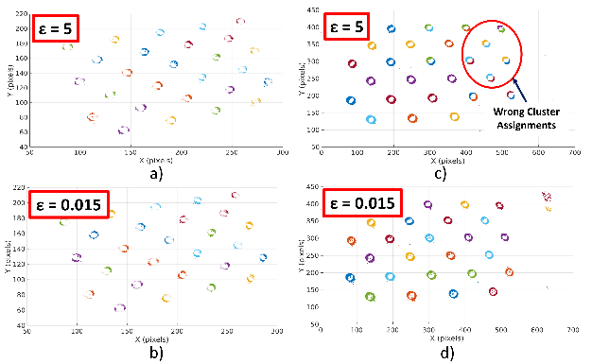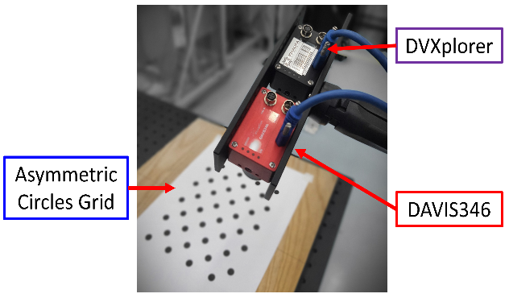
Figure 4: a) and c) clustering using conventional clustering approaches. b) and d) shows our approach. The plots on left and right represent the DAVIS346 and DVXplorer event cameras, respectively.

- The event-based circle detector achieved sub-pixel localization accuracy of the calibration targets and the proposed work has been compared against the state-of-the-art in terms of reprojection error, intrinsic parameters, and detection success rate, see Table 1.
Table 1: The proposed event-based calibration algorithm is benchmarked against the works of Reinbacher et al [24], Muglikar et al. [23], Scheerlinck et al. [28] and Huang et al. [29] on the davis_3x9_fast with 146 total number of applicable detections. The dash indicates the metric is not applicable while † represents failure of obtaining the parameter.
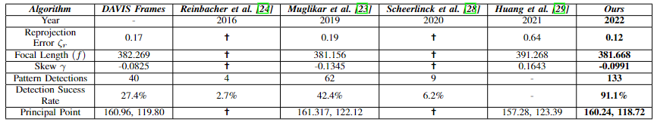

    - KPI summary:
- We are currently testing the countersink inspection using conventional camera at STRATA R&D.
- We are working on an article related to countersink inspection using neuromorphic vision.
- We have submitted an article on neuromorphic camera calibration to the IEEE Robotics and Automation Letters.

- For the vision based tactile sensor:
  - We have addressed the comments from the first round of review for our article titled “A Novel Vision-based Multi-functional Sensor for Normality and Position Measurements in Precise Robotic Manufacturing” from the “Journal of Intelligent Manufacturing”. We have finalized our revision and re-submitted the manuscript

    - KPI summary:
- An article on the visuotactile sensor for robotic deburring has been re-submitted after addressing the reviewer’s comments.

- For the robotic blade sorting project (with SANAD):
  - The perception subsystem is still under testing and further development and enhancement:
- The second stage detection development is finalized, where it re-localizes the blades when in close proximity (currently of a depth between 30 cm and 40 cm, noting some limitations due to the Intel D435 depth camera that is currently being used. And hence:
  - We have conducted market research about available short range depth cameras with sub-millimeter accuracy and high quality images at very close range:
    - Intel D405 stereo camera has been shortlisted and selected to replace the Intel D435 camera where:
      - The D405, as claimed by Intel Corporation is targeted for automated high precision pick and place for small objects at close range (which will help in better localization, gripping, and insertion of blades)
      - The D405 operates at an ideal range of 7 cm to 50 cm and a 0.1 mm object detection at 7 cm, which is very ideal for the blade sorting project.
    - Intel D405 stereo camera has been purchased, received, and utilized:
      - The vision algorithm which we use to detect and localize the blades has been modified to adopt the new camera integration

- Fiducial Marker “ARUCO” has been utilized to apply depth filtering on the output of the blades’ detector algorithm in order to omit any false positives. (Another filtering will be added later which filters any blade detection outside the targeted box to be sorted, which will help in better management for the initial deployment at SANAD’s)
- Physical Sorting has been re-instated, where the system will weigh the blades in the 1st box, generate the sorting sequence, then moves the blades to a new box in sets of HIGH/LOW according to SANAD’s sorting/installation protocols, and then generate the detailed datasheet to guide the human operator in the rotor-installation phase:
  - We are currently working on the clustering algorithm to detect and localize the slots (K-Means clustering is being investigated); Additional filtering will be applied later to ensure correct localization of the slots (such as the area and aspect ratio of the slots)
  - The manipulation part of the Physical Sorting process is also under development

- The End-Effector will be re-designed in order to adopt the new changes (such as the new D405 camera and the it will be modified to a higher level of quality to include all required electronics onboard such as the microcontrollers and the DC-DC converter board); industrial-grade connectors will be utilized as well.
    - KPI summary:
- In progress to develop industrial prototype for SANAD Aerotech.
- Upcoming article on the overall system design and integration of visual guidance algorithms is being initiated.

- For the automated blade inspection (with SANAD):
  - The current progress of blades chord measurement is as follows:
- We are currently investigating the best calibration approach to precisely find the geometrical transformation between the robot’s flange and the laser’s optical center. This will increase the repeatability of results, especially when rotational motion is needed for scanning.

  - For AI-based visual inspection of blades:
- We are currently working on a review paper on blades inspection for airplane engines that will be submitted in Q1 2023.
- We are planning to conduct a retest of all blades and repeat the augmentation of the data to increase our sample size. Our previous iteration yielded 100 images, but we need a total of 10,000 images to utilize medical imaging techniques for our detection purposes. Once we have a sufficient amount of data, we will be training a machine learning model to improve the accuracy of our inspections.
- We are also planning to work on another paper focusing on our contributions to the field that will delve deeper into the technical aspects of our process and its potential impact on the aviation industry.

Gantt Chart
Work Package | Month
 | 1 | 2 | 3 | 4 | 5 | 6 | 7 | 8 | 9 | 10 | 11 | 12
The modification and upgrade of the deburring end-effector.
The development of the painting end-effector
Counter-Sink inspection using: a) camera. b) laser profiler
Neobotix MMO-500 preparation for qualification
Vision Based Tactile Sensing for normality control
Vision Based Tactile Sensing for force/torque estimation and regulation
Vision based navigation of mobile robot
Project Closure and recommendations

Lower-Limb Wearable Exoskeleton for Rehabilitation Assistance

Project Objectives:
- To design and develop a new generation of compliant knee exoskeletons, with improved ergonomic characteristics and optimal interface with the human body (intrinsic safety, lightweight, energy efficiency, effective low-impedance rendering, force control, contact stability).
- To design and manufacture a knee exoskeleton device that can provide rehabilitation assistance for post-stroke hemiplegia and knee injury patients with the implementation of an adjustable stiffness actuator that mimics the changing stiffness of the human knee joint.
- To implement wearable sensorimotor interfaces where a connection between the human sensorimotor system and the control and sense of the compliant exoskeleton can be established.
- To validate the efficacy of human rehabilitation with compliant exoskeletons and to define new paradigms of physical human-robot interaction in clinical applications.
- To transfer the developed technology towards real-life applications through collaboration with clinical collaborators in the UAE (Cleveland clinic, MediClinic).

Project KPIs and Deliverables updates:
- Target (as included in the scope of work):
- A Fully functional knee exoskeleton with the ability to change stiffness along the gait cycle.
- A new model of a novel variable stiffness actuator specially designed for exoskeletons applications.
- Provide a smart human-exoskeleton interface that embeds high-end sensory systems.
- The publication of two research papers.
- A patent on the knee exoskeleton design.
- Training of 3-4 undergraduate students.
- Cumulative Achievements:
- An experimental setup is constructed in ARIC lab for the exoskeleton system testing procedures.
- One proposal titled “Intelligent control and sensing interfaces for a compliant knee exoskeleton towards enhanced human-robot interaction dynamics” is submitted to Emerging Science & Innovation Grant (ESIG).
- A paper titled “Design Optimization of a Variable Stiffness Actuator for Knee Exoskeleton Application” is submitted and under review.
- One article “A compliant knee exoskeleton with stiffness change capabilities along the gait cycle for rehabilitation assistance” is being prepared.
- An optimized model for the variable stiffness actuator is designed. This model is implemented in the knee exoskeleton prototype.
- A prototype of the novel knee exoskeleton design with the ability to adjust stiffness along the gait cycle is provided.
- One Ph.D. project proposal is submitted “Compliant Lower-Limb Wearable Exoskeleton for Rehabilitation Assistance”.
- Training of three senior design groups is completed.
- Senior design project group (1); “Design and Development of a Lower Limb Exoskeleton”.
- Senior design project group (2); “Compliant supernumerary robotic limb for human augmentation”.
- Senior design project group (3); “Design of a smart footwear for innovative monitoring of pressure, humidity, temperature, and risk level of diabetic foot development”.
- Two grants are submitted for CIRA-2021 and SANDOOQ AL WATAN, SWARD -2022.
- Two trainees from Al Nokhba program (NSR) recently joined to be working under the exoskeleton project investigating:
- Structural (Static & Dynamic) stress and force analysis of lower-limb exoskeleton.
- Machine learning and neural network design for exoskeleton control enhancement.
- One patent is submitted and under review by the IP office “irisVSA: infinite rotation infinite stiffness Variable Stiffness Actuator”, KU Tech ID #2021-034, submitted in 2021.

Updates for this month:

- We are currently developing the main controller of the exoskeleton system. Position control is conducted to follow the desired gait trajectory. Results are shown in Fig 1. The position control is deployed using Quanser real-time controller.

- We are working on the revisions of the IRB approval reports that we have submitted before, this is to move forward with the IRBs.
Figure 1: Exoskeleton position control.
KPIs Summary:
- Control and characterization of the compliant exoskeleton prototype.
- An article addressing the knee exoskeleton design and control is to be submitted.

- As part of the Al Nokhba training program, we started developing an intelligent control algorithm based on neural networks and machine learning. As well as an exoskeleton prototype to investigate the comfort and ergonomics.

- Multiple neural networks architectures are deployed for optimal knee joint angles prediction. The methods adopted are Transformer-based solutions for the long-term time series forecasting (LTSF) task. The transformer models used are shown in Fig 2 along with the calculated mean absolute and squared errors.
Figure 2: LTSF neural networks based results.

- Testing is being conducted on the comfort and wearability of the exoskeleton for enhanced grip and slipping reduction between the exoskeleton and the human. New special type of straps with more contact points will be used.
KPIs Summary:
- Training of national candidates.
- Engaging in the development of the exoskeleton porotype and research work.
- Provide a smart human-exoskeleton interface that embeds high-end sensory systems.

Gantt chart:

Materials and Manufacturing: Non-destructive testing of Carbon Fiber Reinforced Thermoplastics.

Project Objectives:

- Publishing a research paper under the title: Graphene-coated Sensors for Strain-monitoring in Advanced Composite Materials.
- Following the progress of a PhD student who is working on thermoplastics carbon fiber PEKK.
Cumulative and new project outputs regarding publications and IP

- Publication and IP updates in December:
  - Graphene Paper under the title : Graphene-coated Sensors for Strain-monitoring in Advanced Composite Materials is 80% done.

Updates for this month

- Graphene Paper under the title: “Graphene-coated Sensors for Strain-monitoring in Advanced Composite Materials” is 80% done. Below is some of the written sections and schematic diagrams:
Abstract
Graphene-coated glass fiber tows have been used to monitor strain and detect damage in composite materials based on glass and carbon fiber reinforced epoxy resin. The graphene sensors were located at different locations within the thickness of the composite and monitored whilst the panels were subjected to out-of-plane loading by a hemispherical indentor. Initial tests on a glass fiber reinforced epoxy composite has shown that the sensors are capable of detecting strain as the plate is loaded transversely and ultimately they can detect the onset of damage associated with the onset of fiber fracture and localized delamination. Cyclic fatigue tests highlighted the repeatability of the sensors as well as their ability to withstand longer term loading. Tests were also undertaken on carbon fiber reinforced epoxy panels, where it is necessary to electrically-insulate the sensors from the conductive carbon fibers. Here again, it has been shown that these simple graphene-coated sensors are capable of monitoring the health of a load-bearing composite plate.

Conclusions
The coating has been shown to be satisfactorily sensitive for monitoring the compression loading. The graphene coated fabrics demonstrated an electrical resistance that changed under applied loading. Full recovery was not achievable, due to some permanent deformation or de-bulking wherein the graphene coated tows buckled due to an inter-tow nesting effect, a phenomena which is more noticeable in 2D fabrics than in 3D fabrics, due to inter-layer and inter-tow nesting [34]. It should be noted that by coating the glass fabric with graphene particles, the overall stiffness of the fabric is slightly increased, as compared to the uncoated tow.

Schematic Diagrams from the paper:
Wire
Copper tape
Graphene sensor
Glass fiber epoxy layer
Figure 1. Schematic diagram shows the components of tested samples

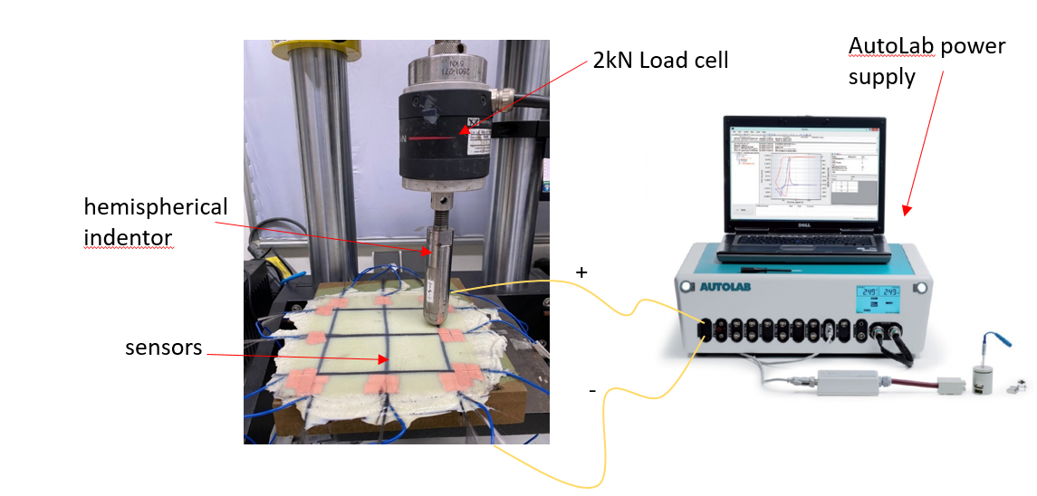
Figure 2. Experimental Setup
- Updates from the PhD student on processing of thermoplastic composites:

- I only continued my DMA tests; Temperature sweep teases and Relaxation tests. In addition to calibrating the relaxation modules using a Generalized Maxwell model for Thermo-Rheological Complex and Three- Network model and the achieved accuracy between experimental results and predicted cause are above 99%.

- Experimentally investigating warpage of Thin flat panels and the effect of laminate and process parameter on the part maximum warpage value.

- I am wrapping up the testing soon and I still need time to analyze the data. From this, I should obtain the CF/PEKK stiffness matrix that considered time, temperature and crystallinity and that will be calibrated later for FEA.

- I also started simulation work for predicting warpage using the three-network model that I calibrated using POLYUMOD software, calibrated figures of the first batch of samples are attached. I am going through a learning curve with the simulation since I've never dealt with user subroutine. Also, we are waiting for IT to fix the ABAQUS license problem, so that's taking some time.
This work is now being extended to stiffened aerospace structures.

Additive Manufacturing

There is no scoped activity with Strata and ARIC.
From January 2023, additive manufacturing including 3D metallic printing will be involved in SANAD project titled ‘’, and possibly in other ARIC projects

2022 KPI’s

#1 Number of Q1 papers published through ARIC’s team:
(Target: 10 papers, 1 per USD $50k invested in research)
10 published articles, and another 3 under review:

# | Title | Journal | Highest percentile | Authors | Status
1 | A visco-hyperelastic approach to model rate dependent compaction response of a 3D woven fabric | Composites Part A: Applied Science and Manufacturing | 96% | Kulkarni S., Khan K.A., Khan K.A., Alhammadi K., Cantwell W.J., Umer R. | Published
2 | Detection of delaminations in AS4/PEEK composite plates using highly nonlinear solitary waves | Composite Structures | 94% | Yoon, Sangyoung; Kim G. Schiffer, Andreas, Cantwell, Wesley J, Kim, Eunho Kim, Tae-Yeona | Published
3 | Rate and temperature dependent compaction-creep-recovery and void analysis of compression molded prepregs | Composites Part B: Engineering | 98% | Naresh K.;Khan K.A., Cantwell W.J., Umer R | Published
4 | In-situ X-ray computed tomography characterization of compaction-creep-recovery response and statistical void analysis of carbon/epoxy prepregs | Composites Communications | 83% | Alahmed N.; Naresh K.b; Khan K.A. Cantwell W.J.;Umer R. | Published
5 | The energy-absorbing characteristics of tubular sandwich structures | Journal of Sandwich Structures and Materials | 87% | Jishi H.Z; Alia R.A., Cantwell W.J. | Published
6 | Real-Time Grasping Strategies Using Event Camera | Journal of Intelligent Manufacturing | 96% | Huang X.; Halwani M.; Muthusamy R.; Ayyad A.; Swart D.; Seneviratne L.; Gan D.; Zweiri Y. | Published
7 | Neuromorphic Vision Based Control for the Precise Positioning of Robotic Drilling Systems | Robotics and Computer Integrated Manufacturing | 99% | Ayyad A.; Halwani M.; Swart D.; Muthusamy R.; Almaskari F.; Zweiri Y. | Published
8 | Neuromorphic Camera Denoising using Graph Neural Network-driven Transformers | IEEE transactions on Neural Networks and Learning Systems | 99% | Y. Alkendi, R. Azzam, A. Ayyad, S. Javed, L. Seneviratne and Y. Zweiri | Published
9 | ConvMixer-based Unet for Segmentation Refinement of Unknown Objects in Cluttered Scenes | IEEE Access | 90% | Huang X.; Azzam R.; Javed S.; Gan D.; Seneviratne L.; Abusafieh A.; Zweiri Y. | Published
10 | Elastomer-Based Visuotactile Sensor for Normality of Robotic Manufacturing Systems | MDPI Polymers | 77% | Zaid, I.M.; Halwani, M.; Ayyad, A.; Imam, A.; Almaskari, F.; Hassanin, H.; Zweiri, Y. | Published
11 | A Novel Vision-based Multi-functional Sensor for Normality and Position Measurements in Precise Robotic Manufacturing | Journal of Intelligent Manufacturing | 96% | Halwani M.; Ayyad A.; AbuAssi L.; Abdulrahman Y.; Almaskari F.; Hassanin H; Abusafieh A.; Zweiri Y. | Under Review
12 | A Multi-Purpose Autonomous Cobot (Mobile Robot) System for Aerospace Machining Application | Journal of Intelligent Manufacturing | 96% | Abdulrahman Y.; AbuAssi L.; Ayyad A.; Ramadan M.; Halwani M.; Ferguson J.; Abusafieh A.; Zweiri Y. | Under Review
13 | Novel Event-Driven Calibration of Bio-Inspired Neuromorphic Vision Sensors | IEEE RA-L | 94% | Salah M.; Ayyad A.; Humais M.; Abusafieh A; Zweiri Y. | Under Review


#2 Number of problems being solved for industry
(Target: 3)

- Three industrial systems developed and ready for deployment:
# | Project | Client / Collaborator | Status
1 | Deburring End-Effector for B787 production line | STRATA | Developed, and ready for deployment
2 | Overall upgrade of the MMO-500 robot | STRATA | Developed, and ready for deployment
3 | Visual Counter Sink Inspection | STRATA | Developed, and ready for deployment

- Three industrial systems has been preliminary validated in lab conditions, and will be developed to deployment-ready stage in 2023:
# | Project | Client / Collaborator | Status
1 | Painting End-Effector for B787 production line | STRATA | Proof-of-concept
2 | Overall upgrade of the MMO-500 robot | SANAD | Proof-of-concept
3 | Automated Blade Inspection | SANAD | Proof-of-concept

#3 Number of UAE nationals deployed on ARIC projects
(Target: 6 including undergraduate activities)

25 students currently on SDP projects in 2022.
6 National Student Recruits working in ARIC for 10 months.

#4 Number of patents filed
(Target: 4 disclosures filed)

Filing of USSN 17/900,843 in the U.S. Patent Office on August 31, 2022. The title of the application is ROBOTIC MANIPULATOR WITH VISUAL GUIDANCE AND TACTILE SENSING.

#5 Number of articles in local/international media highlighting ARIC’s role/achievements KU
(Target: 3)
# | Description | Link | Status
1 | Post on turbine blade repair on KU LinkedIn page |  | Published
2 | Article about Mariam Al-Dhaheri’s research project published in the Innovation Forward Newsletter | Innovation Forward | Khalifa University (researchku.com) | Published
3 | Article on resin-infused thermoplastics published on KU’s website and KU’s LinkedIn page | Innovation Forward | Khalifa University (researchku.com) | Published
4 | Joint promotion video with STRATA has been published in STRATA’s social media pages. | Post about ARIC in STRATA's social media | Published
5 | The upgrade and update of ARIC’s website | ARIC | Advanced Research and Innovation Center | Updated
6 | The University is working with Dr. Yahya to publicize their recent article in a 95th percentile journal. | - | In progress
7 | The ARIC LinkedIn page has been launched | ARIC LinkedIn Page | In progress

ARIC Visitors in December
- H.E. Major General Khalid Al Buainnain visited ARIC on December 19’th
- Dr. Steve Griffiths visited ARIC on December 20’th
- H.E. Zaki Nusseibeh, president of UAEU, visited ARIC on December 20’th
- Mr. Fahas Al Absi visited ARIC on December 20’th
- A delegate from NYUAD visited ARIC on December 13’th

